Name: Vivek Vikram Pundkar

Roll no: 77

GR no: 11910860

Division: C

Batch: 3

**Quick Sort using Randomized method**

--------------------------------------------------------------------------------------------------------------

**Code**:

**// Random selection of pivot**

int RandomPivotPartition(int a[], int low, int high)

{

int pvt, n, temp;

n = rand();

pvt = low + n % (high - low + 1);

swap(&a[high], &a[pvt]);

return Partition(a, low, high);

}

**// Quick Sort algorithm.**

int QuickSort(int a[], int low, int high)

{

int pindex;

if (low < high)

{

pindex = RandomPivotPartition(a, low, high);

QuickSort(a, low, pindex - 1);

QuickSort(a, pindex + 1, high);

}

return 0;

}

**Output:** 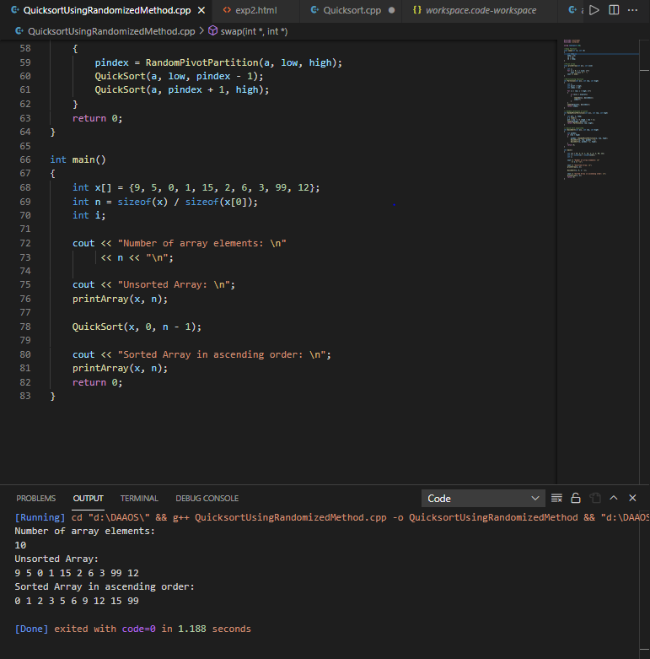

**Analysis:**

**Time Complexity of Quick Sort**

**Best case:**

The partition is evenly balanced, here the pivot element is close to middle number or same as middle number. The best-case complexity of the quick sort algorithm is **O(n logn).**

**Worst case:**

The partition is unbalanced. The worst-case time complexity of Quick Sort is **O(n2).**

**Average case:**

Here the number of chances to get a pivot element is equal to the number of items. The average case complexity of the quick sort algorithm is **O(n logn).**

**Space Complexity of Quick sort**

The space complexity is determined on basis of the space used in the recursion stack. The space complexity of quicksort is **O(n*logn).**